In the Light of Truth

The Grail Message

by Abdruschin

Great Edition
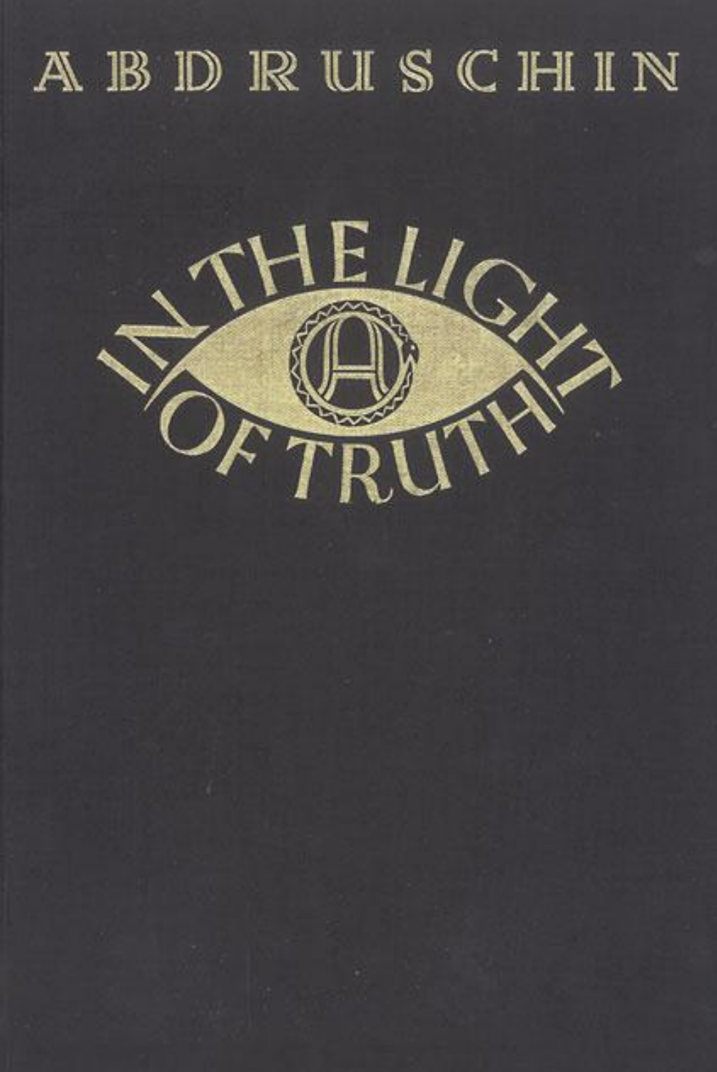In the Light of the Truth - 1931 - Der Ruf - 1934

„Der Ruf“ G. m. b. H. publishing house, Munich - 1934

Book 1) 2) 3)

1)source: edition from 2016 at https://newworldheraldpublishing.com
2)older edition from 2015 at https://www.1931message.com
3)alternative edition from 2010 at abdruschin.ca or lulu

