In the Light of the Truth

The Grail Message

by Abdruschin

Great Edition
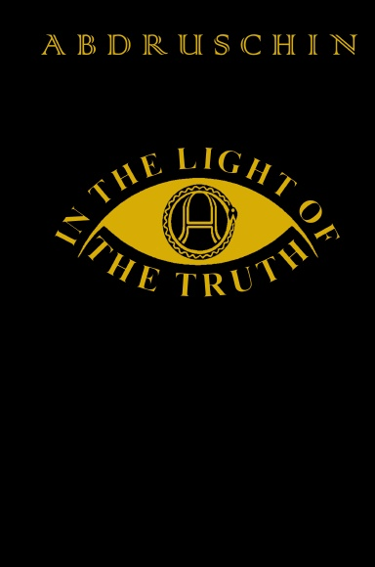In the Light of the Truth - 1931 - Roshan - 2014

Roshan - 2014

Book on lulu:
Paperback Standard, Premium
Hardcover Casewrap, Dustjacket
This translation, published in the years 2008-2014, was undertaken by a native English speaker who was spiritually given the Gift of the German language and did not engage in any prior formal German education whatsoever to fulfil this task.
Please note that no translation can replace the original, and the translator himself recommends that the reader strive to absorb this Work in the original German language.

